Game Design Document

Fill up the following document

1. Write the title of your project.

THE DRAGON OF THE KINGDOM

1. What is the goal of the game?

TO defeat the king vulture TICK

1. Write a brief story of your game.

Hey it’s a magical world but with lots of problems the greatest king of all named greno silk had very arguments with the other greatest king named Patrick’s pic because Greno silk has the rarest species of all the Dragons known as mangu his name is megusa this dragon is very rare and the other king known as Patrick pic want the dragon but the greatest king greno silk doesn’t want to give his dragon to other king so they both had fight and our motive of the game is to take the help of megusa and fight with the other king and protect our castle megusa has 2 powers first he can throw fireballs second he can sneeze on other Dragons with his fireballs the opponent will burn for 0.5 seconds and will disappear and with his sneeze opponent can be statue for one second

1. Which are the playing characters of this game?

* Playing characters are the ones who respond to the user based on the input from the user.
* Cars, monkeys, dinos, wizards, etc., are the playing characters in the game.

|  |  |  |
| --- | --- | --- |
| Number | Character Name | What can this character do? |
| 1 | dragon | Can throw fireballs and sneeze |
| 2 |  |  |
| 3 |  |  |
| 4 |  |  |
| 5 |  |  |
| 6 |  |  |
| 7 |  |  |
| 8 |  |  |

1. Which are the Non-Playing Characters of this game?

* Non-Playing characters are the ones that don't have an action or behavior when the user interacts with the game.
* Hurdles, stones, bananas, coins, etc., are non-playing characters in the game.

|  |  |  |
| --- | --- | --- |
| Number | Character Name | What can this character do? |
| 1 | castle | nothing |
| 2 |  |  |
| 3 |  |  |
| 4 |  |  |
| 5 |  |  |
| 6 |  |  |
| 7 |  |  |
| 8 |  |  |

Draw your imagination of this game. What does this game look like?

* Draw the game either on your computer or on paper.
* Add images of the game scenes to show each of the playing and non-playing characters at least once.

Eg:

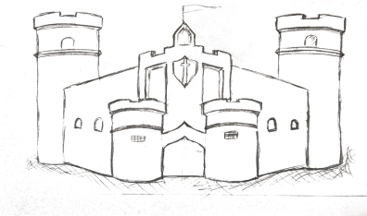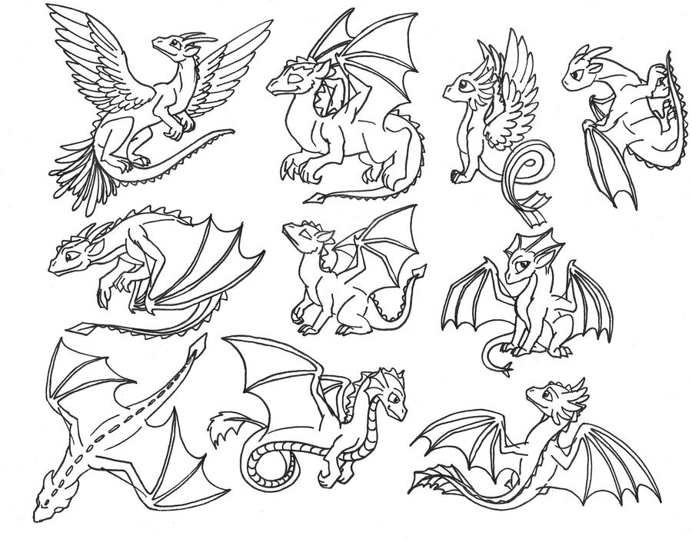

How do you plan to make your game engaging?

the format the story and the game functions